**New Search Box**

**Test Strategy**

|  |  |  |  |  |  |  |  |  |  |  |  |  |  |  |  |  |
| --- | --- | --- | --- | --- | --- | --- | --- | --- | --- | --- | --- | --- | --- | --- | --- | --- |
| |  |  | | --- | --- | |  |  | | Document type | Test Strategy | | Author | Prathima Vyas | | Approver (owner) | Iteration Manager | | Status | Draft | | Issue date | 30/05/2021 | | Revision number | 0.1 | | Classification | UNCLASSIFIED | |

Document control

Revision history

|  |  |  |
| --- | --- | --- |
| Date | Revision | Details including section |
| 30/05/2021 | 0.1 | This is the first release of this document |
|  |  |  |
|  |  |  |
|  |  |  |

Contents

Document control 2

Revision history 2

**1.** **Introduction** 4

**2.** **Approvals** 4

**3.** **Test scope and phases** 4

**4.** **Test environments** 6

**5.** **Test Schedule** 6

**6.** **Test tools** 6

**7.** **Key Test Deliverable Reviewers and Approvers** 7

**8.** **Test dependencies** 7

**9.** **Risks and Assumptions** 7

**10.** **Entry Criteria for testing** 8

**11.** **Exit Criteria for testing** 8

**12.** **Defect management** 8

**13.** **Regression Testing** 9

# **Introduction**

The purpose of this document is to provide the testing approach, test scope, test environment, Risks and Mitigations and type of testing performed for newly introduced “Search box” on the bunnings home page and the results feature.



# **Approvals**

This document should be reviewed and approved. Approvals should be obtained and embedded within this document under the Approval column.

| **Name** | **Role** | **Approval** | **Date** |
| --- | --- | --- | --- |
| TBD | Product Owner |  |  |
| TBD | Iteration Manager |  |  |

# **Test scope and phases**

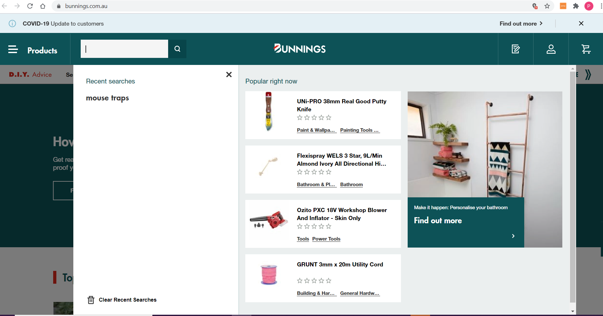

Functionality - Validating if the search box on the bunnings home page enables the user to search the required product on the store and the search box returns the results based on the searched item.

|  |  |  |  |
| --- | --- | --- | --- |
| **Test Phase** | **In Scope** | **Out of Scope** | **Owned By** |
| Unit Testing |  |  | Developer - TBD |
| System testing |  |  | Delivery Team - TBD |
| System-Integration Testing |  |  | Test Lead - TBD |
| UAT Testing || Feedback Sessions |  |  | Business Users - TBD |
| PSUP PVT |  |  | Business Users - TBD |
| PROD PVT |  |  | Business Users - TBD |
| Load Testing |  |  |  |
| Security Testing |  |  |  |
| Performance Testing |  |  |  |

# **Test environments**

|  |  |  |
| --- | --- | --- |
| **Environment** | **Link** | **Test Phase** |
| Development | TBD | Unit Testing |
| Test | TBD | System Testing |
| UAT | TBD | UAT Testing |
| Sandbox | TBD | PSUP PVT |

# **Test Schedule**

|  |  |  |
| --- | --- | --- |
| **Test Phase** | **Schedule** | **Owner** |
| System Testing | TBD | Test Lead - TBD |
| UAT Testing|| Feedback Session | TBD | Business Owner - TBD |
| PSUP PVT | TBD | Business Owner - TBD |
| PROD PVT | TBD | Business Owner - TBD |

# **Test tools**

For the use case in hand, we will perform testing manually and capture the test artefacts in test management tools.

|  |  |
| --- | --- |
| Jira | Testcase Creation, Test Execution, Test Plan, capturing test artefacts, Raising Defects. |
| Confluence | SIT Plan, SIT Completion Report  UAT Plan , UAT Completion Report  PSUP PVT Plan , PSUP PVT Completion Report  PROD PVT Plan, PROD PVT Completion Report. |

# **Key Test Deliverable Reviewers and Approvers**

The table below provides guidance as who reviews and approves the key test deliverable documents.

|  |  |  |
| --- | --- | --- |
| **Artefacts** | **Reviewer** | **Approver** |
| Test Plan | * Delivery Team * Delivery Manager * Business Analyst | * Product Owner * Iteration Manager * Business Owner |
| Test Completion Report | * Delivery Team * Delivery Manager * Business Analyst | * Product Owner * Iteration Manager * Business Owner |

# **Test dependencies**

There are no dependencies on any third-party applications or teams.

# **Risks and Assumptions**

|  |  |  |
| --- | --- | --- |
| **Sl. No** | **Assumptions** | **Risks** |
| 1. | User should be able to launch bunnings application | For testing, we test with few random products . |

# **Entry Criteria for testing**

The following list stands as the “Entry Criteria” for test execution activity,

* Unit Testing must be completed.
* Code should be deployed in Test environment.
* Test activity clearly scoped
* Test environment should be up and running.
* User should have access to the application
* Test cases identified and created based on testable feature .

# **Exit Criteria for testing**

The following list is the “Definition of Done” for test execution activity,

* All acceptance criteria thoroughly tested
* All test cases executed and moved to “Done” in JIRA
* Test execution ticket is moved to “Done” in JIRA
* Test Summary Report updated in confluence
* Any defects identified are raised with enough information like steps to reproduce, logs, environment tested and screenshots in JIRA

# **Defect management**

Any defect identified is to be first discussed with the developer. If it is taking more than 30 minutes for the developer to investigate and if he feels he needs more time, then it is worth raising the defect in JIRA and let the iteration manager know, so they can prioritise it based on priority and severity. When raising defects, it is a good idea to note the following points,

* Defect description is clear and complete
* Defect has clear steps to reproduce
* Defect records the expected outcome and actual outcome
* Defect has logs attached if any
* Defect has screenshots attached if any
* Defect has proper priority and severity assigned
* Defect records the version of software tested
* Defect records the environment it has been tested on
* Defect provides some description about test data used
* Defect mentions the story being tested and specifically the acceptance criteria being tested
* Defect links to the test case ticket and story ticket

# **Regression Testing**

Once the object is modified, it must be regression tested if the existing search functionality is working as expected.